A MAJOR PROJECT REPORT ON
AI-Powered Customer Retention Prediction System
Submitted for Award of Internship Certified for
THE SKILL UNION
Under
VIHARA TECH
Submitted by
GOVULA MEENU
UNDER THE ESTEEMED GUIDANCE OF
Mr.K SAI KAMAL
Assistant Professor
(B. Tech - AI/ML Eng., Data Scientist, CV Eng.)

 | 

DATA SCIENCE
THE SKILL UNION | VIHARA TECH

THE SKILL UNION | VIHARA TECH
VT Plaza, C/14, 4th Floor, Road No:1, KPHB, Kukatpally, Hyderabad, Telangana – 500072

Certificate
This is to certify that the Project Work entitled “Ai-Powered Customer Retention Prediction System” is a Bonafide record of the Industry Oriented Major Project Work submitted by

GOVULA MEENU
Fulfillment of the requirements for the award of the Internship in The Skill Union under Vihara Tech during his/her course duration.

SIGNATURE OF VIHARA TECH  TRAINER  Mr. K Sai Kamal | SIGNATURE OF VIHARA TECH  MENTOR  Mr.Devaram Pranith

SIGNATURE OF THE SKILL UNION
CEO

Mr. K Sai Krishna
DECLARATION

I, G.Meenu, hereby declare that this project report, titled " Ai-Powered Customer Retention Prediction System ", is the result of my original work completed during the 6-month IT/Programming Language training course at Vihara Tech. This project was executed over the full term, incorporating the practical knowledge gained during the four months of intensive classroom training and the real-world experience acquired during the subsequent two-month paid internship at The Skill Union. The information and findings presented herein are a true and accurate reflection of the work performed and have not been submitted, in whole or in part, for any other degree or diploma. I confirm that all sources of information have been specifically acknowledged.

Name | Batch / Course | Signature
GOVULA MEENU | Data Science

ACKNOWLEDGEMENT

The successful completion of this project and the valuable experience gained throughout the six-month training program would not have been possible without the unwavering support and invaluable contributions of several individuals. I extend my deepest gratitude to all those who guided me and facilitated my learning journey.
My sincere appreciation goes to Mr. K Sai Kamal, Data Science & AI/ML Trainer, for their exemplary commitment to education. Their invaluable expertise and clarity in delivering complex programming concepts formed the crucial technical foundation upon which this entire project rests. The dedication they showed in making the classroom sessions truly illuminating has fundamentally shaped my approach to software development.
I am profoundly thankful to my dedicated Institute Mentor, Ms. Tanya. Their steadfast guidance during both the project development and the subsequent two-month internship was instrumental in bringing this report to fruition. Their insightful suggestions, technical foresight, and willingness to offer practical mentorship at critical junctures were truly inspiring and elevated the quality and direction of the work presented here.
Finally, I wish to acknowledge the visionary leadership of Mr. K Sai Krishna, CEO of The Skill Union. It is through their strategic stewardship that the Skill Union has created an outstanding environment, fostered a culture of excellence and provided career-defining opportunities like the one I have just completed. This initiative has been a powerful launchpad for my professional trajectory.
This project has been a significant milestone, and I am grateful for the collective efforts that made this comprehensive learning experience possible.

Table of Contents

S. No. | Chapter  No | Section Title | Page No.
1 |  | Cover Page | 1
2 |  | Certificate | 2
3 |  | Declaration | 3
4 |  | Acknowledgement | 4
5 |  | Table of contents | 5-7
6 |  | Architecture | 8
7 |  | Abstract | 9
8 |  | Introduction | 10
9 |  | Requirements of the model development | 11-12
10 | 1 | Data visualization | 13-22
11 | 1.1 | Visualization overview | 13
12 | 1.2 | Churn comparision | 13-14
13 | 1.3 | Dependents with churn | 15
14 | 1.4 | Tenure with churn | 15-16
15 | 1.5 | Multiple lines comparision | 16-17
16 | 1.6 | Monthly charges with gender and churn | 17-19
17 | 1.7 | Contract comparision | 19-20
18 | 1.8 | Paperless Bill comparision | 20-21
19 | 1.9 | Internet Service comparision | 21
20 | 1.10 | Final observations of the visualizations | 22
21 | 2 | Feature Engineering | 23-37
22 | 2.1 | Handling missing values | 23-27
23 | 2.2 | Data separation | 27
24 | 2.3 | Variable Transformation | 27-34
25 | 2.4 | Handling outliers | 34-37
26 | 3 | Feature Selection | 37
27 | 3.1 | Categorical encoding | 37-39
28 | 3.2 | Filter methods | 39-40
29 | 3.3 | Hypothesis testing | 40-41
30 | 4 | Merging | 41
31 | 5 | Data Balancing | 42-43
32 | 6 | Feature Scaling | 43
33 | 7 | Model Training | 44-45
34 | 8 | Hyperparameter Tuning | 45-46
35 | 9 | Best Model | 46-47
36 |  | Result | 47
37 |  | Conclusion | 48
38 |  | Future Enhancements | 48
39 |  | References | 49

Architecture
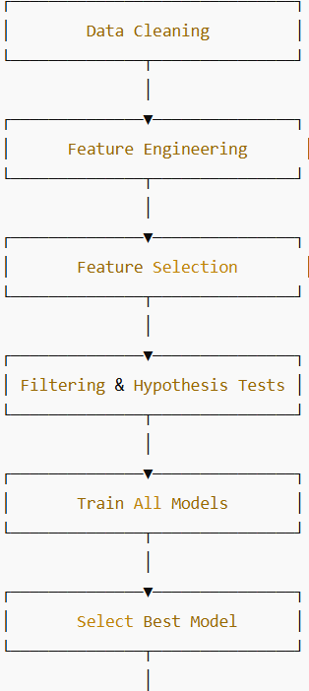
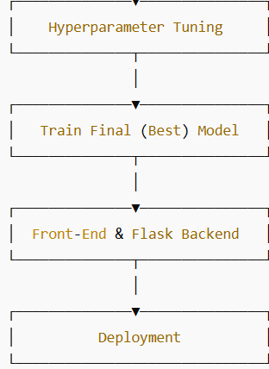

Abstract
Customer retention is a key factor influencing business growth and profitability, particularly in competitive sectors such as telecommunications, banking, and e-commerce. Customer churn, which occurs when customers discontinue a company’s services, directly affects revenue and long-term sustainability. Predicting churn at an early stage enables organizations to take proactive measures to retain customers and improve overall performance.
This project presents an AI-Powered Customer Retention Prediction System developed using machine learning techniques to identify customers who are likely to leave a service in the near future. The system follows a well-defined analytical pipeline that includes data cleaning, feature engineering, feature selection, and statistical hypothesis testing. Data preprocessing involves handling missing values, managing outliers, encoding categorical variables, scaling features, and addressing class imbalance using the SMOTE technique.
Several machine learning models, including Logistic Regression, Decision Tree, Random Forest, XGBoost, and Support Vector Machine, are trained and evaluated using performance metrics such as accuracy, precision, recall, F1-score, and ROC-AUC. The best-performing model is further improved through hyperparameter tuning to enhance prediction accuracy.
Overall, this project demonstrates how machine learning can be effectively leveraged for predictive analytics in customer relationship management, providing a data-driven approach to enhance customer loyalty and organizational profitability.
The optimized model is deployed as a Flask-based web application that provides real-time customer churn predictions. The system supports data-driven decision-making by helping businesses reduce customer attrition and implement effective retention strategies through practical machine learning insights.

Introduction
In the modern digital era, businesses operate in highly competitive markets where customer expectations are continuously evolving. Retaining existing customers has become a strategic priority, as acquiring new customers often involves higher costs compared to maintaining long-term relationships with existing ones. Industries such as telecommunications, banking, and e-commerce are particularly affected by customer churn, which refers to customers discontinuing services due to factors such as dissatisfaction, better alternatives, or pricing concerns. High churn rates can significantly impact revenue, customer lifetime value, and overall business stability.
The increasing availability of customer data, combined with advancements in artificial intelligence and machine learning, has opened new opportunities for predictive analytics in customer relationship management. Machine learning techniques enable organizations to analyze historical customer data, identify complex behavioral patterns, and predict future outcomes with high accuracy. By predicting customer churn in advance, businesses can implement proactive retention strategies, personalize customer experiences, and optimize decision-making processes. Data-driven churn prediction systems help organizations move from reactive problem-solving to proactive customer engagement.
This project presents the development of an AI-Powered Customer Retention Prediction System that leverages machine learning algorithms to predict customer churn. The system follows a structured approach involving data preprocessing, feature engineering, feature selection, and model training using multiple algorithms to ensure robust performance. The optimized model is deployed through a Flask-based web application that allows users to input customer information and receive real-time churn predictions. The proposed solution demonstrates the practical application of machine learning in addressing real-world business challenges and supports organizations in reducing customer attrition and improving long-term profitability.

Requirements of the model development

- blinker – Provides fast, simple object-to-object and broadcast signaling for Python applications.
- click – Used to create command-line interfaces (CLI) in a clean and composable way.
- colorama – Enables cross-platform colored terminal text output.
- contourpy – Handles contour generation for visualizations, used by Matplotlib.
- cycler – Helps in creating composable style cycles, mainly used with Matplotlib.
- feature_engine – Offers feature engineering and preprocessing transformers for machine learning.
- Flask – A lightweight web framework for building web applications and APIs.
- fonttools – A library for manipulating fonts and related binary data.
- gunicorn – A WSGI HTTP server for running Python web applications in production.
- imbalanced-learn – Provides tools to handle imbalanced datasets using over/under-sampling techniques.
- imblearn – Wrapper package that redirects to imbalanced-learn.
- itsdangerous – Used for securely signing data in web applications (e.g., Flask session tokens).
- Jinja2 – A fast, powerful templating engine for rendering HTML templates in Flask.
- joblib – Provides lightweight pipelining and parallel computing utilities for Python.
- kiwisolver – A fast implementation of the Cassowary constraint solver used in layout calculations (e.g., Matplotlib).
- MarkupSafe – Escapes characters in strings to make them safe for HTML/XML output.
- matplotlib – The primary Python library for creating static, animated, and interactive visualizations.
- numpy – The core library for numerical computing and handling large multidimensional arrays.
- packaging – Tools for parsing and handling package versioning and dependency specifications.
- pandas – A powerful library for data manipulation and analysis with DataFrames.
- patsy – Describes statistical models and builds design matrices for statsmodels.
- pillow – The Python Imaging Library (PIL) fork for opening, manipulating, and saving image files.
- pyparsing – A library for constructing and executing grammars used in text parsing.
- python-dateutil – Extends the datetime module for flexible date and time parsing.
- pytz – Enables accurate and cross-platform timezone calculations.
- scikit-learn – A comprehensive library for machine learning algorithms and data preprocessing.
- scipy – Provides scientific computing tools including statistics, optimization, and integration.
- seaborn – A high-level statistical data visualization library built on top of Matplotlib.
- six – Provides compatibility utilities between Python 2 and 3 codebases.
- statsmodels – Used for performing statistical tests, regression, and data exploration.
- threadpoolctl – Controls the number of threads used by native libraries in Python.
- tzdata – Provides timezone database information for systems that lack it.
- Werkzeug – A WSGI utility library that powers Flask’s request and response handling.
- xgboost – An optimized gradient boosting framework for high-performance machine learning

1. Data Visualization
1.1. Visualization Overview
- In this project I used matplotlib and seaborn library for the data visualization to understand and interpret the data.
- It can be installed using the command
pip install matplotlib
- Tools used in the matplot library are:
=>Bar chart
=>Pie chart
- For the statistical analysis of the data I used seaborn library to learn more about the data using charts and graphs.
- It can be installed using the command
pip install seaborn
- Tools used in seaborn library for data analysis are:
=>Hist plot
=>Bar plot
=>Count plot
=>Box plot
- I also used pandas for Data manipulation and preprocessing and Numpy libraries for numerical Operations and to perform scientific calculations.
1.2. 1. Partner Distribution:
This visualization represents the distribution of customers based on their partner status, categorizing them into:
• Customers with a partner
• Customers without a partner
The graph helps analyze how relationship status correlates with customer presence in the telecom service..
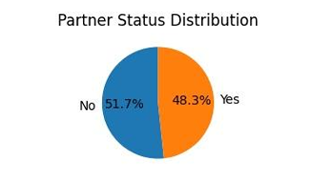
1.3. Churn Distribution:
• This visualization illustrates the overall distribution of customers based on their churn status, categorizing them into:
1.Customers who continued using the telecom service
2.Customers who discontinued the service (churned)
• The graph provides a clear overview of customer retention versus customer loss.
• Each bar represents a churn category (Yes / No).
• Reducing churn directly improves customer lifetime value and revenue stability.
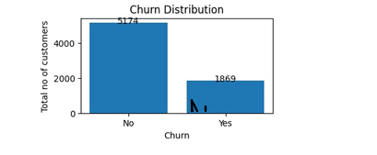
1.4. Churn Possibility Per Sim Distribution:
• This visualization represents the churn possibility across different SIM providers, showing how customer churn varies by SIM type.
• The SIM providers analyzed include:
1. Jio
2. Airtel
3. VI
4. BSNL
• The graph helps identify which SIM providers experience higher customer attrition.
• The height of the bar indicates the number or proportion of customers who have churned for that SIM.
• This visualization enables a direct comparison of churn behavior across providers.
• Certain SIM providers exhibit a higher churn tendency, indicating potential issues related to pricing, network quality, or customer satisfaction.
• SIM providers with lower churn demonstrate stronger customer retention and service reliability.

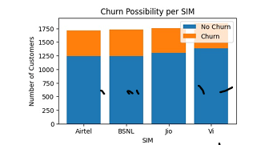

1.5. Year-wise Distribution by Customers:
• This visualization summarizes the year-wise distribution of SIMs taken by customers, highlighting overall SIM acquisition trends across different years.
1.Each bar represents a specific year.
2.The height of the bar indicates the number of SIMs activated in that year.
3.The graph provides a clear comparison of SIM adoption over time.
• Recent trends help determine whether SIM adoption is growing, stabilizing, or declining.
• This distribution complements churn and tenure analysis by showing when customers entered the system.
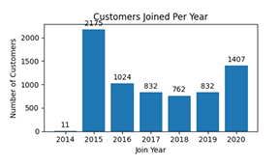
1.6. Total Charges Provided by Sim:
• This visualization represents the distribution of total charges accumulated by customers across different SIM providers.
• Total charges reflect the cumulative amount paid by customers over their entire tenure with a provider.
• The SIM providers analyzed include:
1. Jio
2. Airtel
3. VI
4. BSNL
• SIM providers with a larger customer base or longer average tenure tend to show higher total charges.
• Providers with lower total charges may have higher churn or shorter customer tenure.
• High total charges indicate strong customer loyalty and long-term engagement.
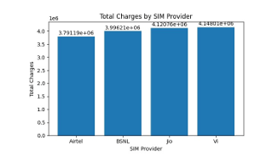

1.7. Average Monthly Charges by Churn:
• This visualization represents the average monthly charges of customers segmented by their churn status:
1. Customers who churned
2. Customers who did not churn
• The objective is to understand whether billing amounts influence customer churn behavior.
• Each bar corresponds to a churn category (Yes / No).
• The height of the bar indicates the average monthly charge for customers in that category.
• The visualization enables a direct comparison of billing levels between churned and retained customers.
• Customers who churned generally have higher average monthly charges compared to those who stayed.
• Customers with lower average monthly charges tend to show better retention.
• Pricing plays a significant role in influencing customer loyalty..
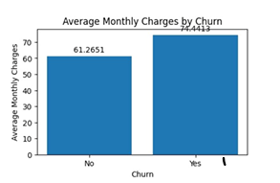

1.8. Average Tenure by Churn:
• This visualization represents the average customer tenure (in months) segmented by churn status:
1. Customers who churned
2. Customers who did not churn
• The objective is to understand how the length of customer relationship impacts churn behavior.
• Each bar corresponds to a churn category (Yes / No).
• The height of the bar indicates the average tenure of customers in that category.
• The visualization provides a clear comparison of customer longevity between churned and retained users.
• Customers who did not churn have a significantly higher average tenure.
• The likelihood of churn decreases as tenure increases.
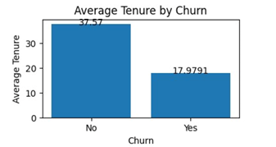

1.9. Gender Distribution Among Senior Citizens:
• This visualization represents the distribution of senior citizen customers based on gender, categorizing them into:
1. Male senior citizens
2. Female senior citizens
• Each bar corresponds to a gender category among senior citizens.
• The height of the bar indicates the number of senior customers in each gender group.
• The visualization highlights gender-based participation within the senior citizen population.
• Senior male customers often constitute a slightly higher proportion compared to female senior customers.
• Senior citizens, regardless of gender, typically show higher churn sensitivity due to pricing, service complexity, or support needs.
• Gender differences among senior citizens can influence service usage patterns and support requirements.
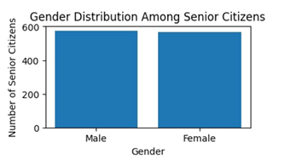
1.10. Paperless Billing:
• This visualization represents the distribution of customers based on their paperless billing preference.
• Customers are categorized into:
1. Customers who have enabled paperless billing
2. Customers who have not enabled paperless billing
• This analysis helps understand customer adoption of digital billing practices.
• Each bar corresponds to a paperless billing category (Yes / No).
• The height of the bar indicates the number of customers in each category.
• The visualization provides a clear comparison between digital and traditional billing preferences.
• A significant portion of customers have opted for paperless billing, indicating growing acceptance of digital services.
• Customers who use paperless billing often show higher engagement with online platforms.
• Non-paperless billing customers may prefer traditional communication or have lower digital adoption.
• Paperless billing users are frequently associated with lower churn risk when combined with auto payment options.
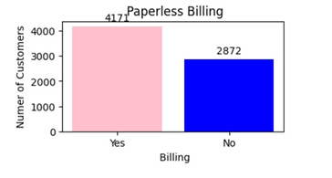
1.11. Streaming Movies:
• This visualization represents the distribution of customers based on their subscription to the Streaming Movies service.
• Customers are categorized into:
1. Customers who have Streaming Movies service
2. Customers who do not have Streaming Movies service
3. Customers with no internet service, where streaming is not applicable
• This analysis helps understand the adoption level of entertainment-related value-added services.
• Each bar corresponds to a Streaming Movies service category.
• The height of the bar indicates the number of customers in each category.
• The visualization clearly differentiates between streaming subscribers and non-subscribers.
• A substantial number of customers have not subscribed to the Streaming Movies service.
• Customers with internet service are more likely to adopt streaming services.
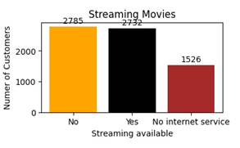
1.12. Streaming TV:
• This visualization represents the distribution of customers based on their subscription to the Streaming TV service.
• Customers are categorized into:
1. Customers who have Streaming TV service
2. Customers who do not have Streaming TV service
3. Customers with no internet service, where streaming services are not applicable
• Each bar corresponds to a Streaming TV service category.
• The height of the bar indicates the number of customers in each category.
• The visualization highlights how widely Streaming TV is adopted among customers.
• Streaming TV adoption is higher among customers with reliable internet services.
• Customers subscribed to Streaming TV generally demonstrate higher engagement and loyalty.
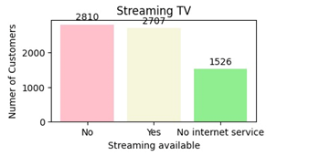
1.13. Tenure Distribution:
• This visualization represents the distribution of customers based on their tenure, i.e., the length of time (in months) they have been associated with the telecom service provider.
• Tenure is a key indicator of customer loyalty and service engagement.
• Each bar corresponds to a tenure range (in months).
• The height of the bar indicates the number of customers within that tenure range.
• A large proportion of customers fall within the lower tenure range, indicating many customers are relatively new.
• Customer count gradually decreases as tenure increases, suggesting churn is more likely during the early stages.
• Customers with longer tenure represent a smaller but more stable and loyal segment.
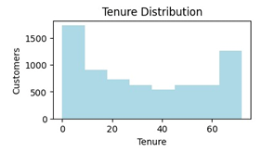
1.14.Contract Distribution:
• This visualization represents the distribution of customers based on the type of contract they have subscribed to.
• The contract types typically include:
1. Month-to-Month contracts
2. One Year contracts
3. Two-Year contracts
• This graph helps in understanding customer commitment levels and service stability.
• The height of the bar indicates the number of customers subscribed to that contract.
• The visualization clearly differentiates between short-term and long-term customer commitments.
A large proportion of customers are subscribed to month-to-month contracts, indicating a preference for flexibility. • Month-to-month contracts are typically associated with higher churn risk.
• Long-term contracts reflect stronger customer trust and satisfaction.
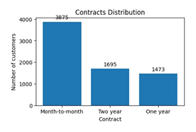
1.15. Customers by Dependents:
• This visualization represents the distribution of customers based on their dependent status, categorizing them into:
1. Customers with dependents
2. Customers without dependents
• Dependent status is an important demographic factor that influences customer needs, service preferences, and retention behavior.
• Each bar corresponds to a dependent status category (Yes / No).
• The height of the bar indicates the number of customers in each category.
• A larger proportion of customers do not have dependents, indicating a significant segment of individual or single users.
• Customers without dependents tend to be more price-sensitive and flexible, increasing their churn risk.

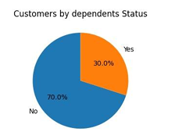
1.16. Customers by Multiple Lines:
• This visualization represents the distribution of customers based on whether they have multiple phone lines subscribed under their account.
• Customers are categorized into:
1. Customers with multiple lines
2. Customers with a single line
• 3.Customers with no phone service
• This analysis helps understand customer usage patterns and service complexity.
• Each bar corresponds to a multiple-lines category. • The height of each bar indicates the number of customers in that category.
• Customers with multiple lines generally show higher engagement and lower churn risk
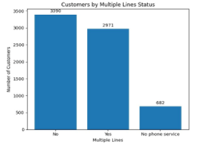

1.17. Gender Distribution:
• This visualization represents the distribution of customers based on gender, categorizing them into:
1. Male customers
2. Female customers
• Each bar corresponds to a gender category.
• The height of the bar indicates the total number of customers belonging to that gender.
• The visualization offers a clear comparison of male and female representation within the telecom customer base.
• Gender distribution helps in understanding overall customer composition.
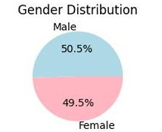
1.18. Phone Service Distribution:
• This visualization represents the distribution of customers based on whether they have subscribed to the phone service offered by the telecom provider.
• Customers are categorized into:
1. Customers with phone service
2. Customers without phone service
• This graph helps assess the adoption level of basic telecom services among customers.
• Each bar corresponds to a phone service category (Yes / No).
• The height of each bar indicates the number of customers in that category.
• The visualization provides a clear view of how widely phone services are used within the customer base.
• The majority of customers have subscribed to phone services, indicating it is a core offering.
• A smaller segment of customers does not use phone services, possibly relying on alternative communication platforms.
• Lack of phone service may indicate customers who are more likely to churn or switch providers.
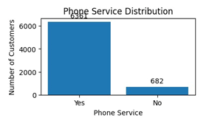
1.19. Senior Citizens:
• This visualization represents the distribution of customers based on senior citizen status, categorizing them into:
1. Senior citizens
2. Non-senior citizens
• This analysis helps in understanding the proportion of elderly customers within the overall telecom customer base.
• Each bar corresponds to a senior citizen category (Yes / No)
• The height of the bar indicates the number of customers in each category.
• The visualization provides a clear demographic split between senior and non-senior customers.
• The majority of customers belong to the non-senior citizen category. • This group often exhibits higher churn sensitivity due to cost, technology usage, or service complexity.

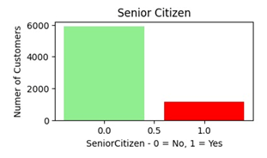
1.20. Sim Services:
• This visualization represents the distribution of customers based on the services subscribed under their SIM connection.
• SIM services typically include:
1. Phone Service
2. Internet Service
3. Streaming Services
• The graph helps understand how customers utilize different services provided through their SIM.
• Each bar corresponds to a specific SIM service category.
• The height of the bar indicates the number of customers subscribed to that service.
• Value-added services have comparatively lower adoption, highlighting potential upselling opportunities.
• Customers subscribed to multiple SIM services tend to have higher engagement and lower churn probability.

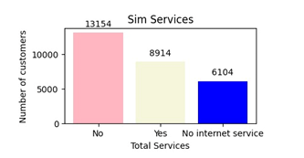
S
1.21. Sim’s Taken by Year:
• This visualization summarizes the year-wise distribution of SIMs taken by customers
• Each bar represents a specific year.
• The height of the bar indicates the number of SIMs activated in that year.
• The graph provides a clear comparison of SIM adoption over time.
• Years with higher bars indicate strong SIM acquisition, often driven by promotions, competitive pricing, or market expansion.

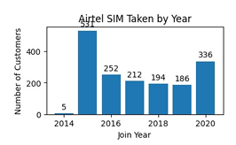
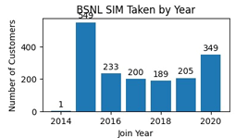
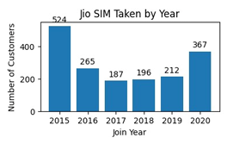
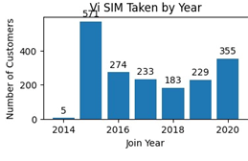
1.22. Share of Sim:
• This visualization represents the distribution of customers based on the SIM provider they are using.
• The SIM providers included in the analysis are:
1. Jio
2. Airtel
3. VI
4. BSNL
• Each bar corresponds to a SIM provider.
• The height of the bar indicates the number of customers using that particular SIM.
• One or two SIM providers dominate the customer base, indicating stronger brand presence and service reach.
• SIM providers with lower customer counts may face competitive challenges such as pricing or network coverage.
• SIM distribution provides a foundational understanding for further churn and performance analysis by provider.

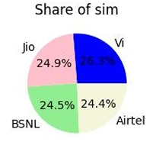
1.23. Payment Method:
• This visualization represents the distribution of customers based on the payment methods they use to pay their telecom bills.
• Common payment methods include:
1. Electronic Check
2. Credit Card (Automatic)
3. Bank Transfer (Automatic
4. Mailed Check
• This graph helps understand customer payment preferences and billing behavior.
• Each bar corresponds to a specific payment method.
• The height of the bar indicates the number of customers using that payment method.
• The visualization provides insight into how customers prefer to manage their payments.
• A significant number of customers use electronic check, indicating a preference for manual or flexible payment options.
• Customers using automatic payment methods (credit card or bank transfer) generally show more stable behavior.
• Manual payment methods are often associated with higher churn risk.

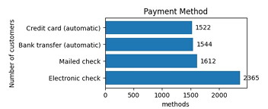
2. Feature Engineering
- Feature Engineering is the process of transforming raw data into meaningful features that better represent the underlying patterns in the dataset, thereby improving model performance.
- After the clear visualization on the data I have moved to the feature engineering phase where at first I have seen whether the missing values present in the data or not. After performing operations on the data I have found no null values in the data.
- Then I separated the data to categorical and numerical data. After the separation I have found the missing values in the ‘Total Charges’ column due object data type in the Total Charges column as the values in the column are numbers.
- So for handling these missing values there are several methods. After checking some of the best methods I have finalized the best method in handling those missing values.
2.1. Handling Missing Values
- Random Sample Imputation:

- Random Sample Imputation is a technique used to handle missing values by replacing them with randomly selected existing values from the same variable in the training dataset.
- This approach helps maintain the original shape, mean, and variance of the data distribution, making it a better alternative to mean or median imputation, which can distort the feature’s natural pattern.
- After applying random sample imputation, the standard deviation shows a large change compared to the original data, indicating that the variability of the feature is not well preserved. Therefore, this method was not chosen for handling missing values in the dataset.
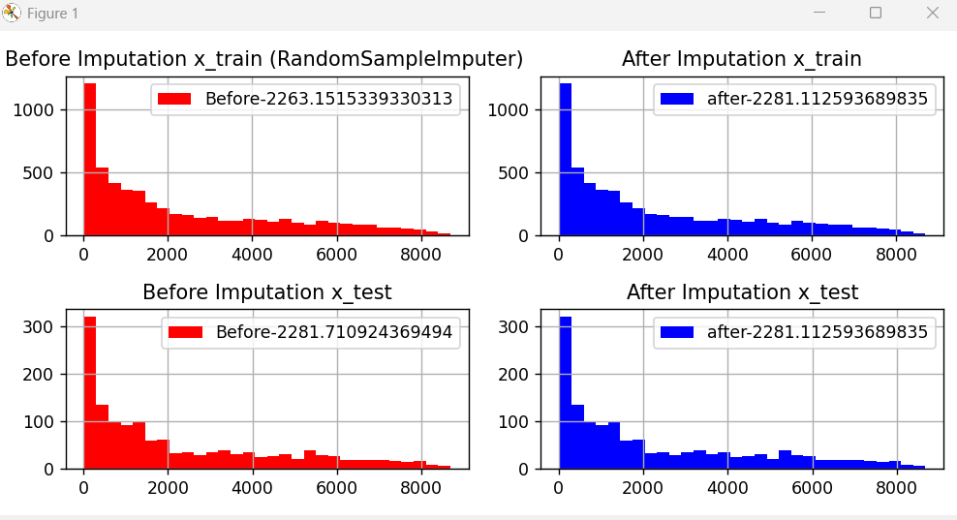
Fig.1 Random sample imputation

- Mean/Median/Mode
- Mean Imputation replaces missing values with the average of the feature, slightly smoothing the data while keeping the overall distribution close to the original.
- Median Imputation fills missing values using the middle value, preserving data spread and reducing the effect of outliers.
- Mode Imputation substitutes missing values with the most frequent value, mainly useful for categorical data and maintaining common patterns in the dataset.
- Drop Missing Data
Dropping missing data (deletion) is one of the simplest techniques for handling missing values, where rows or columns containing missing entries are removed from the dataset.
• Unlike imputation methods such as mean, median, or KNN, this approach does not estimate missing values but directly eliminates them.
• However, using this technique can lead to the loss of important information if a large number of rows or columns are removed.
• This method is most effective when the percentage of missing values is very small (typically less than 5%), as it minimizes data loss and does not significantly affect the overall datase• t.

- Constant, Arbitrary, End of Distribution Imputation:

- Constant Imputation replaces missing values with a fixed constant such as 0, −1, or “Unknown”. It is simple to apply and helps preserve the number of records, but the chosen value may introduce bias if not selected carefully.
- Arbitrary Imputation fills missing values using a random or manually chosen value that does not necessarily come from the data distribution. It is useful for clearly marking missing data but can distort the feature distribution.
- End of Distribution Imputation replaces missing values with extreme values (very small or very large) at the ends of the data distribution. This method helps models identify missingness as a separate signal and is often used in tree-based algorithms.
2.2. Data Seperation:
- In any churn prediction dataset, the features (columns) are usually a mix of numerical and categorical variables.
- Before applying transformations such as scaling, encoding, or imputation, it’s essential to separate them.
- Once the missing values are handled with the best techniques I have gone through the categorical and numerical data separation.
- Machine learning algorithms understand numbers, not categories or text.
- However, numerical and categorical data represent information very differently, so we handle them separately before training.
- So this had done simply by checking their data type and separated to categorical and numerical data using select_dtypes() pandas function.

2.3. Variable Transformation:
- variable transformation (also called feature transformation) is a data preprocessing step used to modify the values of variables (features) to make them more suitable for statistical analysis or machine learning models.
- Many ML algorithms (like linear regression, logistic regression, etc.) assume data is normally distributed. Transformations make data more symmetric.
- Transformations reduce the effect of extreme values.
- It improves the predictive capability of churn models and leads to more reliable business insights.
- Let’s see some of the techniques that I have worked on.

- Power Transformation:
- A Power Transformation is a mathematical technique used to make data more normally distributed (symmetrical and bell-shaped) and to stabilize variance across features.
- You apply a power function to transform the data:
x′=x^λ
- where λ (lambda) controls how much the data is transformed.
- However, in practice, we don’t manually pick λ the algorithm automatically finds the best λ that makes the data as close to normal as possible.

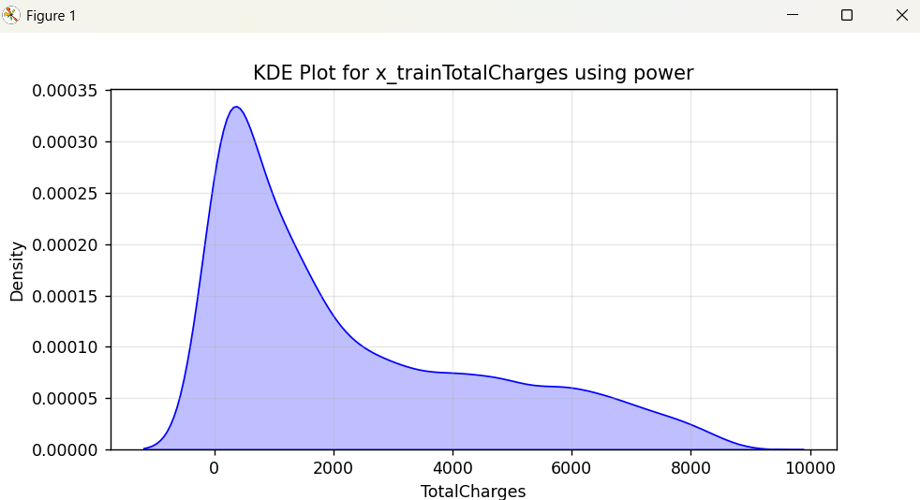
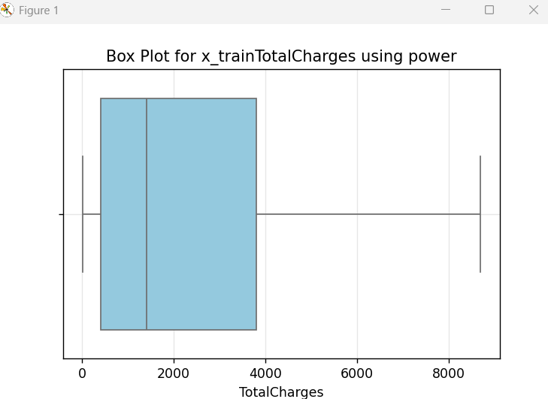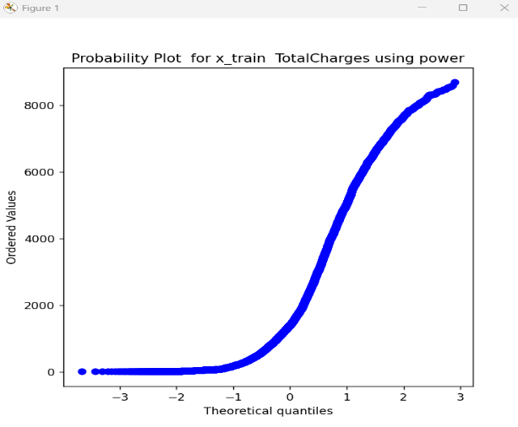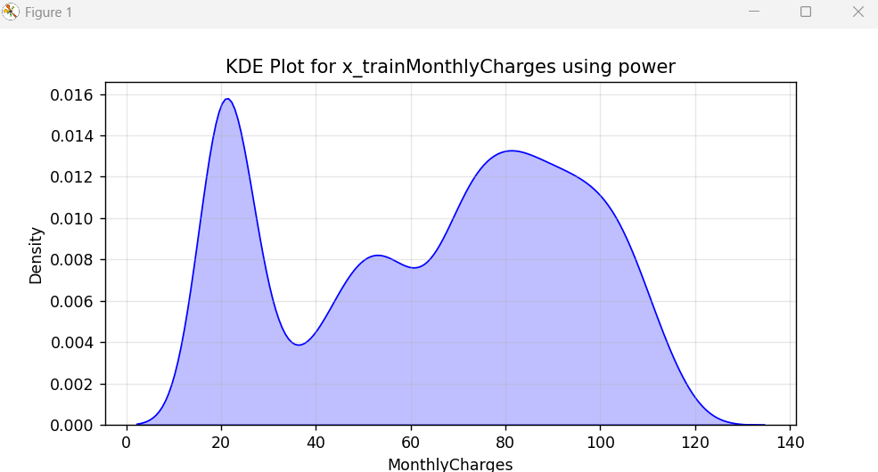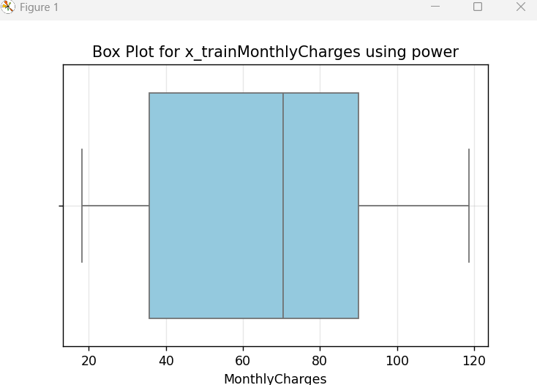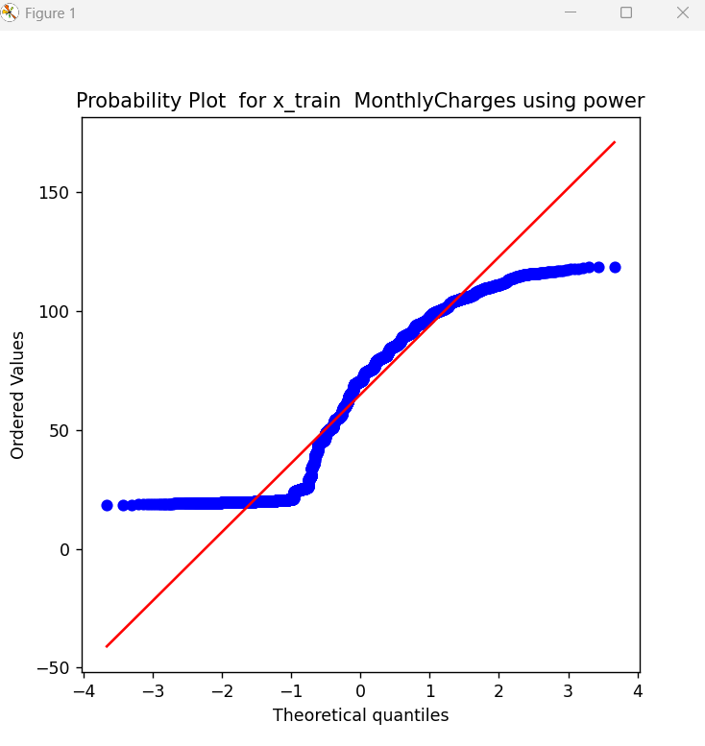
- After applying this method I did not get the bell curve of the normal distribution graph which indicates the data is normally distributed and also probability graph has not given proper outcome.so I did not choose this method for transformation.

- Box Cox Transformer:
- class feature_engine.transformation.BoxCoxTransformer (variables=None)
- The BoxCoxTransformer() applies the BoxCox transformation to numerical variables.
The Box-Cox transformation is defined as:
- T(Y) = (Y exp(λ)−1) /λ if λ!=0
- log(Y) otherwise
- where Y is the response variable and λ is the transformation parameter. λ varies, typically from -5 to 5. In the transformation, all values of λ are considered and the optimal value for a given variable is selected.
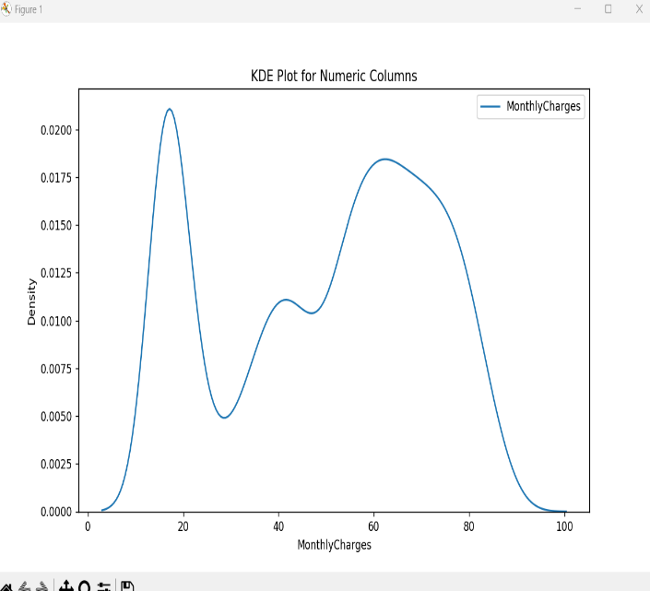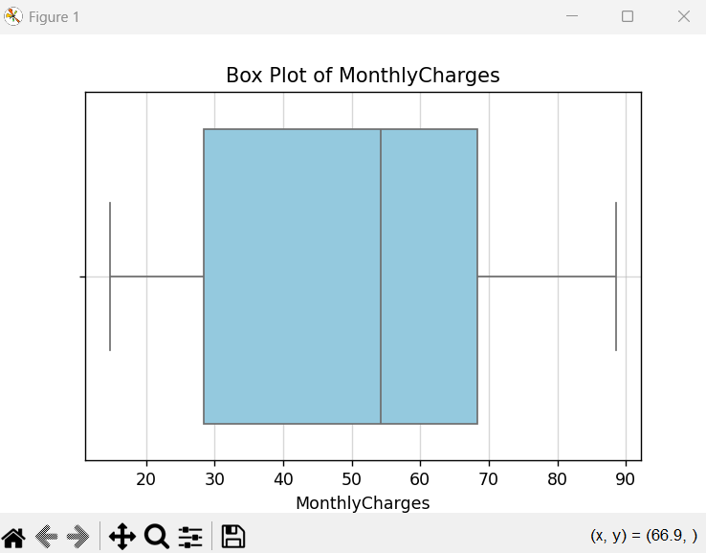
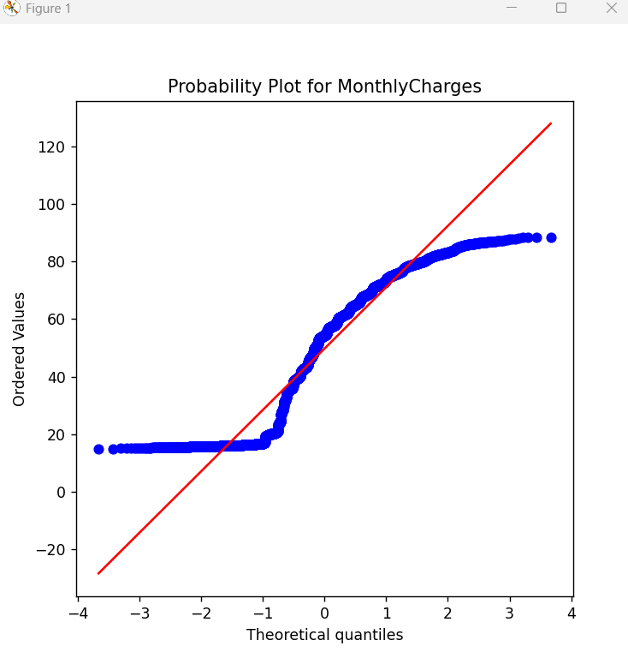
- After applying this method I did not get the bell curve of the normal distribution graph which indicates the data is normally distributed and also probability graph has not given proper outcome.so I did not choose this method for transformation.

- Arcsin Transformer:

- The ArcsinTransformer() applies the arcsine transformation to numerical variables.
- The arcsin transformation, also called arcsin square root transformation, or angular transformation, takes the form of arcsin(sqrt(x)) where x is a real number between 0 and 1.
- The ArcsinTransformer() only works with numerical variables which values are between 0 and 1. If a variable contains values outside of this range, the transformer will raise an error.
- This method has not given the expected results based on the data.So I have not used this technique in the model building process.

- Log Transformer:
- The LogTransformer() applies the natural logarithm or the base 10 logarithm to numerical variables. The natural logarithm is the logarithm in base e.
- The LogTransformer() only works with positive values. If the variable contains a zero or a negative value the transformer will return an error.
- A list of variables can be passed as an argument. Alternatively, the transformer will automatically select and transform all variables of type numeric.
- This method has not given the expected results based on the data. So I have not used this technique in the model building process.
- Yeo–Johnson Transformation (Best Approach)
- The Yeo–Johnson transformation is a power-based, parametric feature transformation technique used in machine learning to reduce skewness and make numerical features more normally distributed. It is an extension of the Box–Cox transformation and is especially useful for real-world datasets because it can handle both positive and negative values, making it more flexible and widely applicable.
- Unlike the Box–Cox transformation, which requires all input values to be strictly positive, the Yeo–Johnson transformation can be directly applied to data containing zero or negative values without any prior shifting. The transformation is controlled by a parameter λ (lambda), which determines the shape and strength of the transformation. This parameter is automatically estimated from the data using maximum likelihood estimation, ensuring an optimal transformation for the given feature.
- Mathematical Formulation:
- For a feature value $x$, the Yeo–Johnson transformation $y$is defined as:
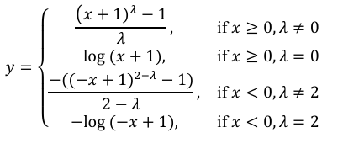
- This transformation improves data symmetry, stabilizes variance, and enhances the performance of many machine learning models that assume normally distributed inputs.

2.4 Handling Outliers:
- Handling outliers is a crucial preprocessing step to ensure data consistency and model reliability.
- After the data is normally distributed we will check whether the outliers are present in the dataset. As we saw in the above box plot graphs there are outliers present in the dataset. Outliers are data points that differ significantly from most of the other observations in a dataset.
- Outliers can distort the data distribution and mislead machine learning models. So now we need to handle the outliers for better model training.
- Techniques like Arbitrary Outlier capper, Winsorization and Log Transformation effectively minimize the influence of extreme values in the dataset in which columns we find the outliers leading to more robust churn prediction results.

- Capping (Outlier Capping):
- Outlier capping is a technique used to control extreme values in numerical features that may negatively impact model performance, training stability, and prediction accuracy. Instead of removing outliers from the dataset, this method limits their effect by capping values at predefined lower and upper thresholds, thereby preserving all data points while reducing the influence of extreme observations.

- Any value below the lower threshold is replaced with the lower cap, and any value above the upper threshold is replaced with the upper cap. While this approach is simple and easy to apply, it is not fully data-driven, as it depends heavily on manually chosen threshold values.

- If these thresholds are not selected carefully, the method may either over-cap or under-cap feature values, resulting in information loss and distortion of the original data distribution. Due to these limitations and the potential risk of introducing bias, outlier capping was not used in the final model-building process
- Trimming(Best Approach)
  - Outlier Trimming is a technique used to handle extreme values by completely removing records from the dataset when feature values fall outside predefined statistical limits.
  - A commonly used method is the Interquartile Range (IQR) approach, where observations outside the range
([Q1 - 1.5 \times IQR,; Q3 + 1.5 \times IQR])
are treated as outliers and removed.
  - Another popular approach is the Z-score method, in which observations are eliminated if the absolute standardized value exceeds a chosen threshold:
(|Z| > \text{threshold}).
  - Although trimming reduces the influence of extreme values, it removes entire data points that may represent meaningful or rare but valid cases—an important consideration in churn analysis.
  - Excessive trimming can result in significant data loss and biased samples, which can negatively impact model generalization and performance.
  - Due to these drawbacks and the risk of losing valuable information, the Outlier Trimming technique was not included in the final model-building pipeline.

- 5th and 95th Quantile:
- The 5th and 95th quantile technique is used to handle extreme values by defining lower and upper bounds based on percentile thresholds of the data distribution.
- Values below the 5th percentile are replaced with the 5th quantile, and values above the 95th percentile are replaced with the 95th quantile, reducing the influence of outliers while retaining all observations.
- This method is more data-driven than manual capping, as the thresholds are derived directly from the feature distribution.
- However, if the data contains genuine extreme values, this approach may still compress important information and slightly distort the original distribution.
- Due to this potential information loss, the 5th and 95th quantile method must be applied carefully and was evaluated but not preferred for the final model-building process.

3. Feature Selection
3.1. Categorical Encoding:
- Feature selection is the process of identifying and retaining the most significant variables that contribute to predicting customer churn while removing irrelevant or redundant features.
- After feature engineering I have moved to the next phase of model development which is feature selection.
- In the feature selection at first we need encode all the categorical columns which means machine learning model trains on numerical values so all the categorical columns should be encoded to numericals.
NOTE: From the data for the categorical column conversions we will use onehot encoding technique for the nominals and for ordinals we will use ordinal encoding.If the dependent columns are categorical we will use Label encoding which are the best techniques.

- One Hot Encoding:
- From the categorical columns the Nominals we are having are 'gender','SeniorCitizen', 'Partner','Dependents','PhoneService','MultipleLines','InternetService','OnlineSecurity','OnlineBackup','DeviceProtection','TechSupport','StreamingTV','StreamingMovies','PaperlessBilling', 'PaymentMethod'.
- For a categorical variable with N unique categories, One-Hot Encoding creates N new columns (dummy variables).Each column corresponds to one category, and takes a value of:
1 → if the record belongs to that category
0 → otherwise
- Only one of these columns will have a 1 per row that’s why it’s called “one-hot” encoding.
- Ordinal Encoding:
- From the categorical columns the ordinals we are having is only the ‘Contract’ column.
- Ordinal Encoding replaces each category with an integer value that represents its order or rank.
- Ordinal Encoding should be used when:
- The categorical variable has a clear order or ranking (ordinal data).
Examples:
  - Education Level → High School < Bachelor < Master < PhD
  - Satisfaction → Poor < Average < Good < Excellent
  - Size → Small < Medium < Large
- The order between categories has meaningful significance for the model.
- Label Encoding:
- Label Encoding is a categorical data encoding technique used to convert textual or categorical values into numeric form.Each unique category in a feature is assigned an integer value.
- Label Encoding is a key preprocessing step in Customer Churn Prediction that converts categorical data into a numerical format, enabling machine learning algorithms to process it effectively.
- The categorical variable has no ordinal relationship between categories (nominal data).
Example: Gender → Male = 0, Female = 1.

3.2. Filter Methods:
- Filter methods are one of the main types of feature selection techniques used in machine learning.
- In simple terms, they filter out irrelevant or less important features before training the model — just like a sieve that removes noise from useful information.
- We have two techniques in filter methods:
- Constant Technique:
- This technique filter out irrelevant or less important features before training the model based on the variance of every independent column.
- So if the variance of the column is 0 we will remove that column as it does not have any affect on the model data.

- Quasi Constant Technique:
- This technique filter out irrelevant or less important features before training the model based on the variance of every independent column.
- So if the variance of the column is 0.1 we will remove that column as it does not have any impact on the model data.
Note: After checking the columns, as the variance of every individual numeric column is not either 0 or 0.1. So I have not implemented any filter technique in this model.
The variance of a dataset is defined as:
Var(X)=n−1/∑(xi​−xˉ)2​
- Xi->each data value
- xˉ->mean of the data
- n->number of observations

3.3. Hypothesis Testing:
- Hypothesis testing is used to understand data relationships, selecting significant features, and validating assumptions.
- Techniques in hypothesis testing are z-test,T-test,Annova-test,Chi-Square test and corelation is also used to find the insights.
- I have checked with some of the techniques:
- Anova-Test:
- Anova(Analysis of Variance) is a statistical hypothesis test used to compare the means of three or more groups to determine whether they are significantly different from each other.
- It Identify whether at least one group mean differs significantly from others.
- It is used for comparing more than two groups.
- Chi-Square-Test:(Best Approach)
- The Chi-Square (χ²) Test is a statistical hypothesis test used to determine whether there is a significant relationship between two categorical variables or whether the observed frequencies differ from the expected frequencies.
- It checks if two categorical variables are related or independent.
- Chi-Square works good with the categorical data and gives the significance level of each features.so it is used in model development.
- After performing the chi-square test we will get the p_values.so if the p_value of the features is <0.05 we will remove those features.
- Chi-Square test represents the probability that the observed differences (or relationships) in the data could have occurred by random chance.
- Where p_value 0.05 is the significance level or difference.If p_value is less than 0.05 those features are removed.
- Correlation:
- Correlation Hypothesis Testing is a statistical technique used to determine whether two continuous variables are significantly correlated.
- To test correlation, we use the Pearson correlation coefficient (r) and compute the p-value.
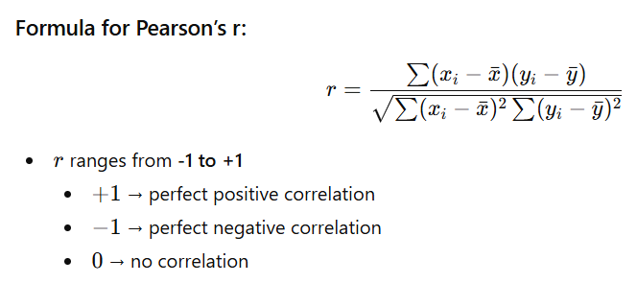
4.Merging:
- As we know for the above processes we have splitted the data to categorical and numerical for checking the strength of the data for the model building.
- As we completed the checking the strength of the data,inorder to train the model we need to combine both numerical and categorical data for training and testing.
- So we will merge both numerical categorical data for both training and testing using pandas concat function.
5. Data Balancing:
- In real-world datasets, the target variable often has unequal class distributions.
- Such imbalance can cause models to become biased toward the majority class, leading to poor performance on the minority class — which is often the most important one.
- So to solve this data imbalance problem we will use some of the techniques to balance the data like oversampling, undersampling and smote(synthetic minority over sampling technique).
- In this project we will use the smote technique which is an advanced technique of oversampling.
- The SMOTE algorithm works as follows:
- For each minority class sample, find its k nearest neighbors (usually k=5).
- Randomly choose one or more of these neighbours.
- Generate a new synthetic sample somewhere between the chosen sample and its neighbour.
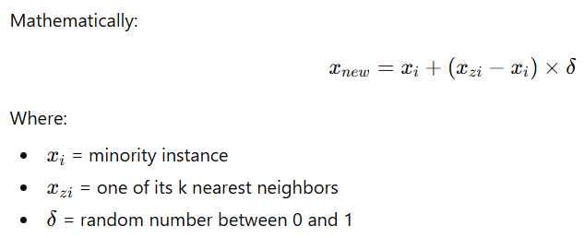
6. Feature Scaling:
• Feature scaling is a data preprocessing technique used to adjust the range of numerical features so that they are on a similar scale before training a machine learning model.
• Many machine learning algorithms perform better and converge faster when input features have comparable scales, especially distance-based and gradient-based models.
• In this project, StandardScaler (Z-score normalization) was used for feature scaling, which transforms features by subtracting the mean and dividing by the standard deviation.
• This technique ensures that the data has a mean of 0 and a standard deviation of 1, helping improve model stability, performance, and training efficiency.

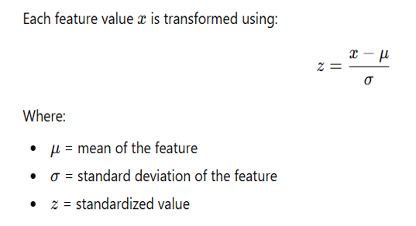

7. Model Training:
- Finally the data is ready for model training.
- Since the dependent column in the data is having binary data we will use Binary classification.
- For the classification we have several algorithms.so we will use all the classification algorithms in the model training and train them.finally the algorithm which gives the best result will be taken as the final algorithm and build the model with that algorithm.
- Using Auc and Roc curves we will finalize the best algorithm.
- ROC curve shows how your model’s performance changes as the decision threshold changes.
- AUC gives a single score to summarize how well the model distinguishes positive from negative classes.
- AUC (Area Under the Curve) represents the degree or measure of separability between the classes.
- It tells us how well the model can distinguish between churned and non-churned customers.
- The ROC curve is a graphical plot that illustrates the performance of a classification model at various thresholds.
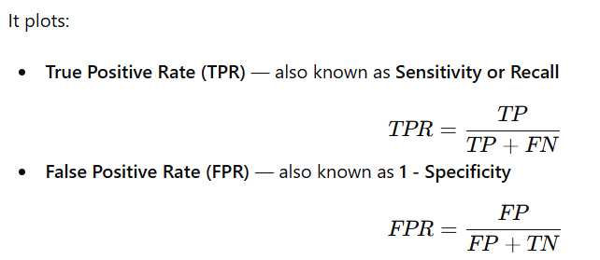
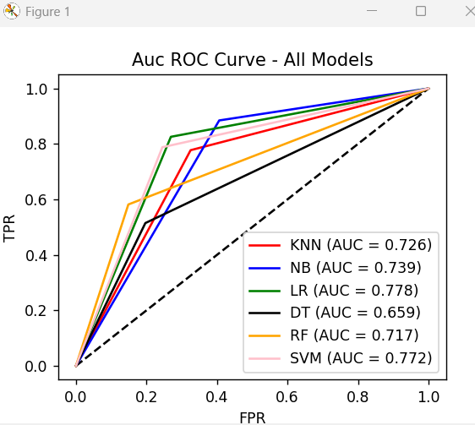
- Since the Auc score is having more for Logistic regression.we will build the model using Logistic Regression.

8. Hyperparameter Tuning:
- Hyperparameter tuning is the process of the selecting best combination of hyperparameters that maximize model performance.
- After the algorithm is finalized for model building we will find the best parameters of the algorithm for better performance of the model.
- Finding the best parameters can be done using Grid search cv and Randomized search cv.
- Grid Search tests all possible combinations of specified hyperparameter values and selects the combination that performs best using cross-validation.
- In Randomized search cv instead of trying all combinations, it randomly samples a fixed number of parameter combinations from the grid.
- So for our model for finding the best parameters I used Grid Search cv.
- GridSearchCV (Grid Search with Cross-Validation) is an automated method to:
- Search through a grid (set) of hyperparameter combinations
- Train models for each combination
- Evaluate performance using cross-validation
- Return the best parameters and the best model

9. Best Model:
- Logistic Regression predicts the probability that an observation belongs to a particular class.
- The output is between 0 and 1 or Yes or No. Where, Yes refers to 1 and No refers to 0.
- Once the model is trained with this algorithm we will evaluate the algorithm on the test data set using confusion matrix and classification report and accuracy of the model.
- Once it is done the best model is saved using pickle for model deployment.
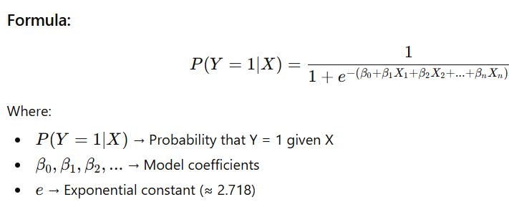
- The sigmoid function converts any real number into a value between 0 and 1.
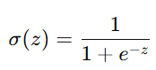

Result:
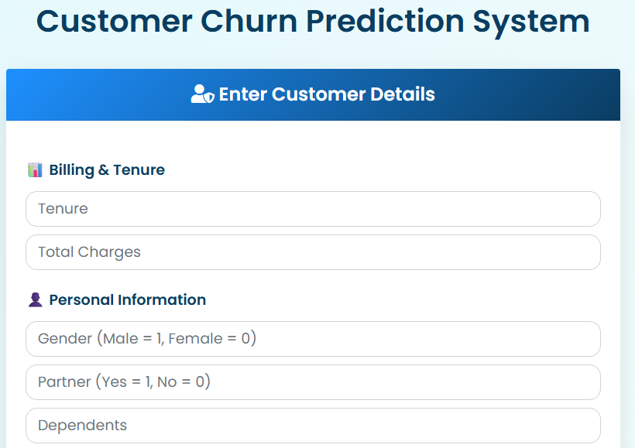
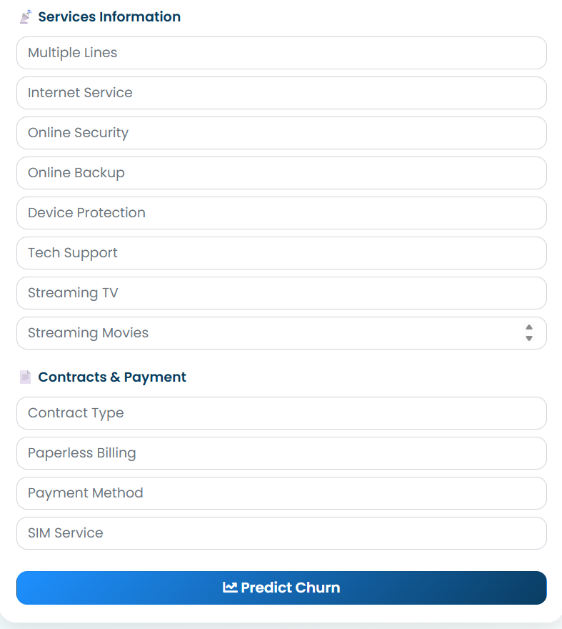

Conclusion:
The Customer Churn Prediction project successfully demonstrates how machine learning can be leveraged to help telecom companies identify customers at risk of leaving their services. By analyzing key customer attributes — such as demographics, service usage patterns, contract type, and billing information — the model provides valuable insights into customer behavior and churn tendencies.The data is cleaned with all the possible best techniques and given the data to the model.After giving the data to the model we will train the model with all the machine learning algorithms.Using Auc and Roc curves I have finalized the model with the Logistic Regression algorithm. Now the model is predicting the output as churn w.r.to Yes or No with the accuracy of 75 percentage.
The project also includes a Flask-based web dashboard, providing an intuitive interface where users can input customer details and instantly view churn predictions. This integration bridges the gap between machine learning models and practical business decision-making.

Future Enhancement:
• Incorporate advanced deep learning models such as ANN and CNN to improve prediction accuracy by capturing complex, non-linear relationships in customer data.
• Integrate real-time data pipelines to enable continuous churn monitoring and timely identification of at-risk customers.
• Develop an interactive visual analytics dashboard to track churn trends, customer behavior, and model performance over time.
• Implement deep learning architectures like ANN, LSTM, and CNN to effectively detect non-linear patterns and sequential dependencies in customer data for more robust churn prediction.

References:
- https://www.kaggle.com/datasets/blastchar/telco-customer-churn
- https://feature-engine.trainindata.com/en/latest/api_doc/index.html
- https://scikit-learn.org/stable/index.html

